Aim:

Design Christmas LED chaser light.

Apparatus:

Connecting Wires, Resistances, Arduino, LED.

Circuit Diagram:

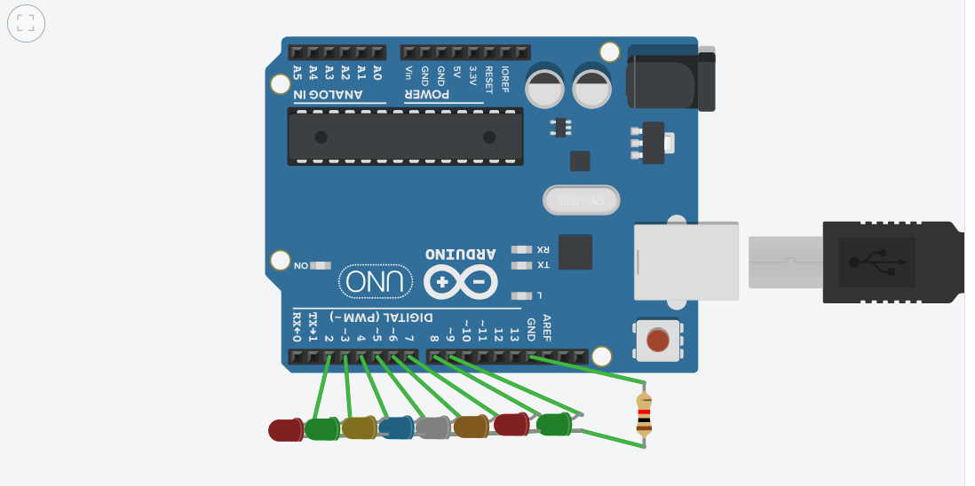

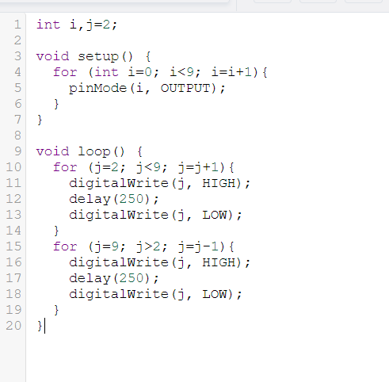

Theory :

LED is a light emmiting diode that gives light as a output. It is a semiconductor. They require very less power to get lighted and work very efficiently.

Arduino:
An Arduino UNO is a device that is equipped with digital and analog input/output slots. It has 14 Input/Output slots, 5 Analog slots and can work between 7 to 20 volts.It has 3 ground pins. It works when user inputs code into arduino.

Concept Used :

One leg of each LED is inserted into the input/output pin of the arduino. The other leg is connected to the resistance and the resistance is connected to the ground slot of the arduino .

Observation :
Chasing of LED is observed after uploading the code.
Learning Outcomes:

- Learned how to make a LED chaser.
- How to code for multiple LED.
- How to make LED's glow in different sequence.

Problems :

- Connections of LED may not be connected properly.
- LED's may not be working.
- Code may be wrong
- Arduino is not working.

Troubleshooting:

- All connections should be checked properly.
- Arduino should be working.
- LED's that are in working conditions should be used.
- Right code must be used.

Precaution:

- Don't plug in an LED without a current limiting resistor.
- Don't supply more than 9V unless proper knowledge.
- Check all the connections.

